**Recommendation System Solution**

* Conducting EDA and understood that 2182 users have rated 9659 books on a scale of 10.

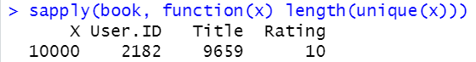

* Created a “realratingmatrix” and by using “popular” method got following recommendation for 5 books for users 8 to 10:

